* Create a Kali VM in your PC
* Download and place the script **DVWA_install.sh** inside the root directory of Kali VM

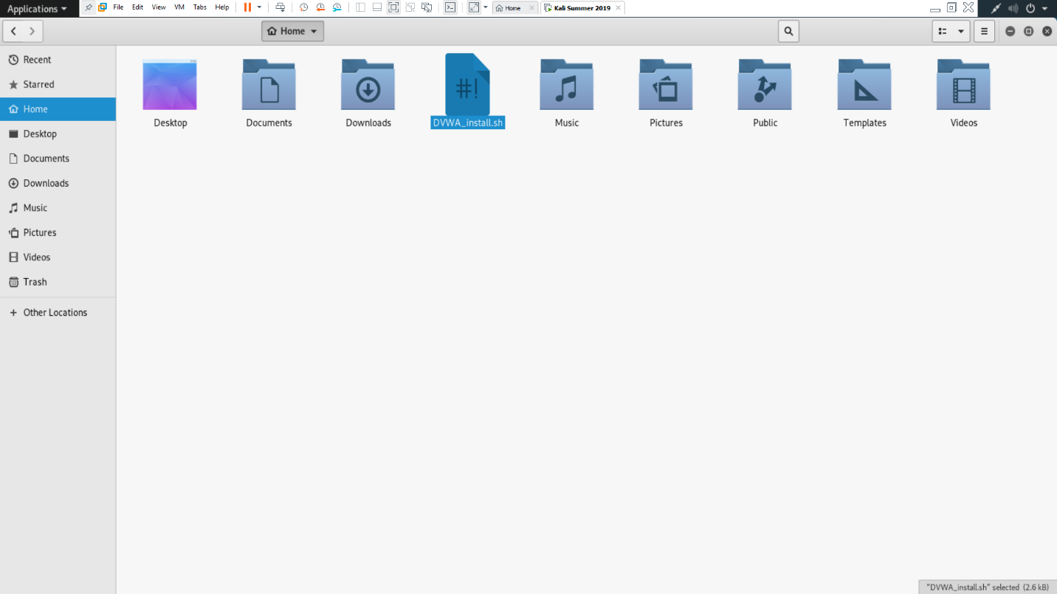

* Give execute permission to the script: **chmod 755 DVWA_install.sh**

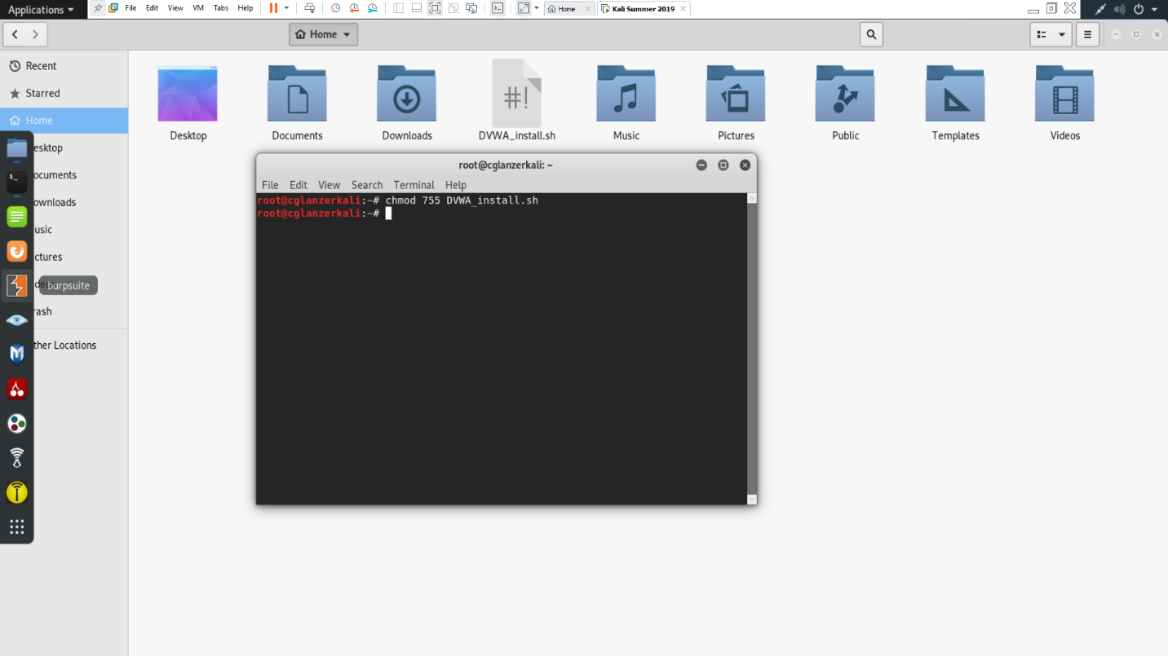

* Execute the script: **sh DVWA_install.sh**

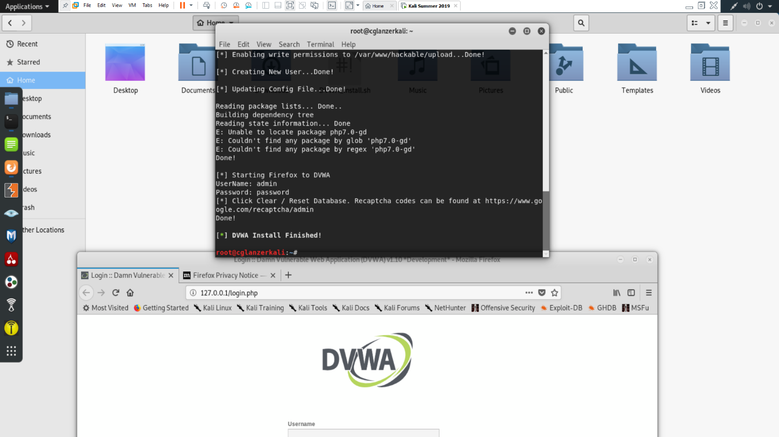

* Reset the database

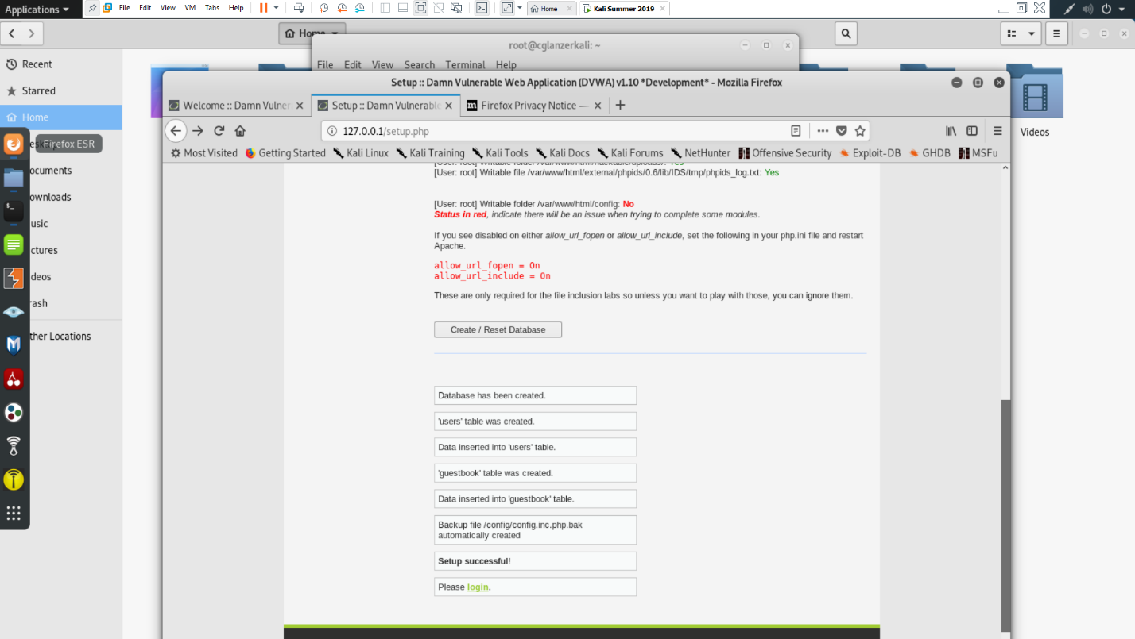

* Login with username/password: **admin/password**
* Change the security setting to low in a drop down list

